Algebra 3-4 Name: _______________________
Worksheet 1.3 Block: ______

Combine like terms.

1. 5a+3b+8a+b 2. 12x-6y-4x 3. –w+n+3w-5w

4. 5a(2a+3b)-2ab 5. -7(6+2x-5y)+2-x 6. 8+2x-6

Evaluate the expression.

7. 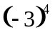 8. 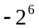

9. 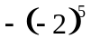 10. 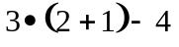

11. 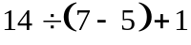 12. 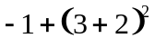

13. 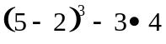 14. 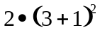

15. 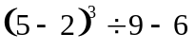

Evaluate the expression for the given value(s) of variable(s).

16. x(2 + x) when x = -5 17. 3x – 0.5(x + 1) when x = 3

18. 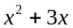 when x = 4 19. 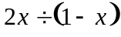 when x = 5

20. 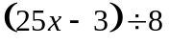 when x = 3 21. 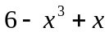 when x = -2

22. 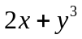 when x = 3 and y = -2 23. 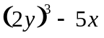 when x = 2 and y = 1

24. 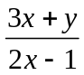 when x = 3 and y = 1 25. 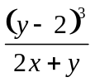 when x = -1 and y = 4

